common name: common backswimmer

scientific name: *Notonecta glauca* (Linnaeus, 1758) (Hemiptera: Notonectidae)

**Introduction – Distribution – Description** **– Behavior – Selected References**

**Introduction**

*Notonecta glauca*, the common backswimmer, is an aquatic insect most easily recognizable by their long hind legs and ability to inflict wounds to humans with their proboscis (mouthpart). Insects in the family Notonectidae are commonly referred to as backswimmers or greater water boatman. They propel themselves through the water on their dorsal side with their abdomen facing upwards. Insects commonly referred to as lesser water boatman are in the family Corixidae, not Notonectidae like common backswimmers.

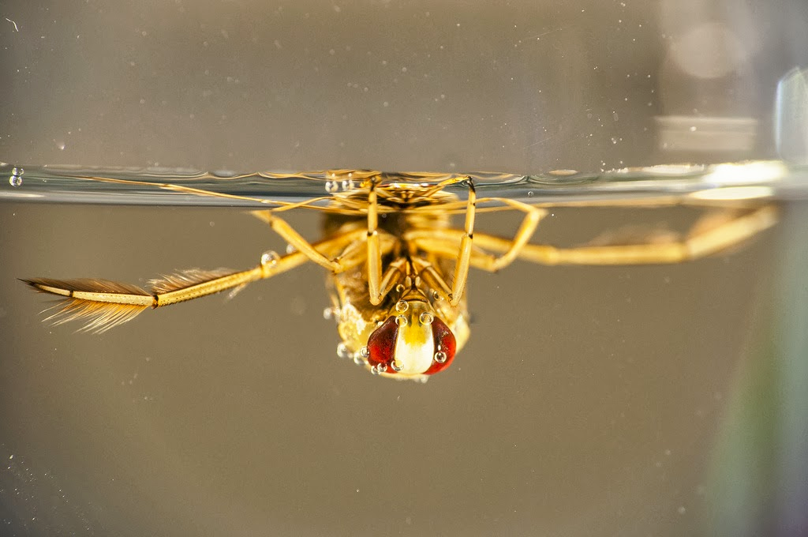

**Figure 1.** *Notonecta* sp. adult resting upside down underwater. Photograph by JRxpo. Flickr.com

**Distribution**

Although most commonly found in Europe, the common bacskswimmer can range from some parts of northern Africa to west Siberia and north western China (Berchi, 2013; Soós et al. 2009). *Notonecta glauca* is most commonly found in freshwater ponds more inland, they can also be found in eutrophic (water excessively enriched in nutrients) bodies of water near the sea (Kjærstad et al. 2009).

**Description**

**Eggs:** *Notonecta* sp. eggs have white oblong eggs and are attached to vegetation.

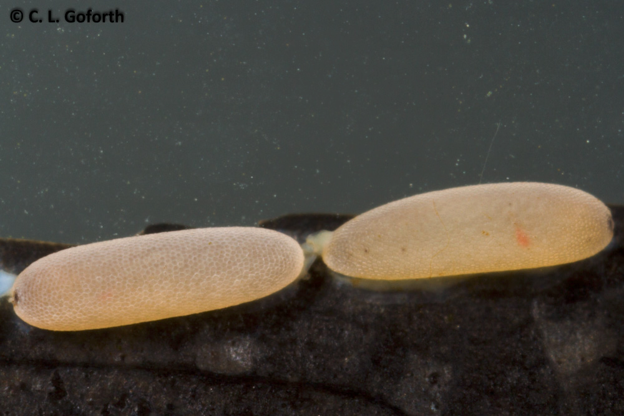

**Figure 2.** *Notonecta* sp. eggs on vegetation. Photograph by Chris Goforth. <https://thedragonflywoman.com>

**Nymphs:** Like many true bugs, nymphs of this species look like smaller adults. They do not have fully developed wings in the nymphal stage and have much shorter abdomens. They are often more uniform in color. Often, their pronotum is not darker than the rest of the body as seen in the adults.

**Adults:** The most easily identifiable feature of insects in the Notonectid family are their long hind legs that they use to propel themselves in the water. Adults of this species have a pale tan head and legs. The pronotum is darker than the head and the elytra (hardened forewings) can be a range of tan colors. The eyes are larger and dark red in color. Fully grown adults measure about 16 mm (Reynaldi et al. 2011).

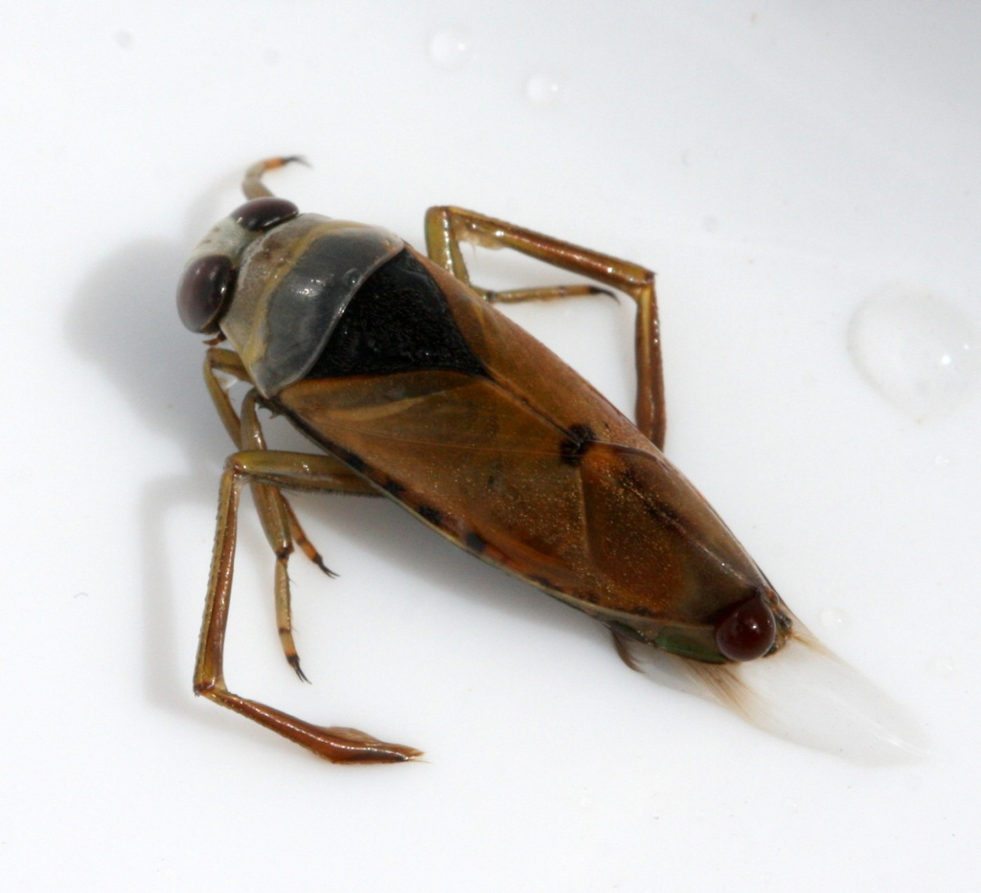

**Figure 3.** An adult *Notonecta glauca*. Photograph by David Nicholls.

*Notonecta glauca* breathes by taking in air, however its body is covered in hair-like structures called setae and microtrichia that aid them in their aquatic lifestyle. Setae are considered true hairs due to the fact that they have a socket from which they are contained residing in an adjacent cell deeper in the exoskeleton. Microtrichia originate from one cell on the surface. A backswimmer’s entire body except the pronotum (area behind the head), head, and legs are covered in these hairs. The hairs create an air film that allows the insect to absorb oxygen from trapped air while underwater and keeps their bodies dry (Kuru et al. 2011). The tips of these hairs are bent in the distal direction, or away from the body, and the area from the root up is pointed in the caudal direction, or towards the back of the body before bending distally. The setae tend to be larger and sparser in comparison to the denser patches of microtrichia. 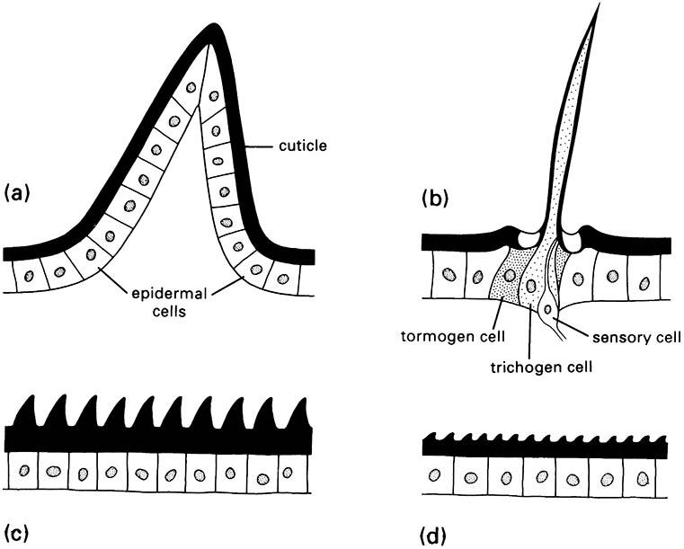

**Figure 4.** Insect skin cell types. A) multicellular spine, B) seta, C) acanthae, and D) microtrichia. Diagram from After Richards & Richards 1979.

There is solely microtrichia present under the upper side of the elytra. Due to the density of the microtrichia air can be held in the film for up to 130 days. The underside of the body that resides under the elytra is sparser than the underside of the elytra itself, which can hold air for longer than the 130 days. Areas that are predominantly covered in setae will lose its air before the 130 days. This air film can be seen by the naked eye, it appears as a silvery sheen on the body (Kuru et al. 2011)

**Behavior**

The common backswimmer preys on a variety of other aquatic organisms like *Daphnia* spp. (water fleas) (Giller and McNeill 1981). *Notonecta* spp. most commonly prey on other insect species, but has been observed to prey on fish eggs, fry, and tadpoles (González and Leal 2010). Notonecta glauca has been observed to prey on the larvae of the mosquito Culex pipens (Reynaldi et al. 2011).When hunting for prey, the common backswimmer captures its prey by using its raptorial fore legs or mid legs (Giller and McNeill 1981). They are ambush predators and wait for an opportunity to strike unsuspecting prey (Ellis and Borden 1970, Giller and McNeill 1981). Because of this, the common backswimmer prefers environments with lush vegetation to hide itself. If there are plants available, the common backswimmer will reside on the edge of the plant in the middle section and this preference is not influenced by the prey selection. Residing on the edge of the plant allows the common backswimmer to more easily observe its surroundings and snatch passing prey (**Figure 1**). (Giller and McNeill 1981). Due to its preference for vegetation and low affinity for the surface, the common backswimmer does best in a complex environment where avoiding the surface and having ample vegetation to hide in will protect it from predation.

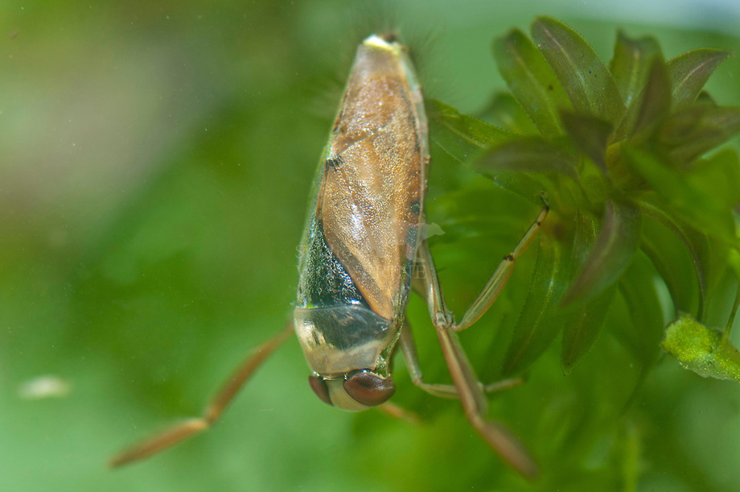

**Figure 5**. *Notonecta glauca* (Linnaeus) adult perched on aquatic vegetation. ©Dick Klees/Studio Wolverine

The common backswimmer sucks the prey item of its resources. In the genus *Notonecta,* *Notonecta glauca* has been recorded to extract food slower and have less of a response to surface activity to than other species. One reasoning for comparatively less response to surface activity is that they prefer to stay at lower depths rather than at the surface of the water (Cockrell 1984). At temperatures below 15 °C (59 °F) it prefers to spend the majority of the time underwater, however above 15 °C (59 °F) it will spend more time above water. At 5 °C (41 °F), it tends to stay completely submerged as much as possible. The common backswimmer also prefers to stay submerged at higher temperatures if the water is more oxygenated (Cockrell 1984).  *Notonecta glauca* also makes less prey-capturing attempts and does best in areas of high prey abundance compared to other species in its genus (Giller and McNeill 1981).

**Selected References**

Berchi G. 2013. Checklist and distribution of the family Notonectidae in Romania, with the first record of *Notonecta maculata* Fabricius, 1794 (Hemiptera: Heteroptera: Nepomorpha)*.* Zootaxa 3682: 121-132.

Cockrell BJ. 1984. Effects of temperature and oxygenation on predator-prey overlap and prey choice of *Notonecta glauca*. Journal of Animal Ecology 53: 519-532.

Ellis RA, Borden J. 1970. Predation by *Notonecta undulata* on larvae of the yellow fever mosquito. Annuals of the Entomological Society of America 63: 963-973.

Giller PS, McNeill S. 1981. Predation strategies, resource partitioning and habitat selection in *Notonecta* (Hemiptera/Heteroptera). Journal of Animal Ecology 50: 789-808.

González A, Leal J. 2010. Predation Potential of Some Aquatic Insects (*Pantala*, *Coenagrion*, *Tropisternus,* *Notonecta* and *Sigara*) on Common Carp Fry. Journal of Applied Aquaculture 5: 77-82.

Kjærstad G, Dolmen D, Olsvik HA, Tilseth E. 2009. The backswimmer *Notonecta glauca* L. (Hemiptera, Notonectidae) in Central Norway. Norwegian Journal of Entomology 56: 44-49.

Kuru PD, Schneider ES, Melskotte JE, Brede M, Leder A, Barthlott W. 2011. Superhydrophobic surfaces of the water bug *Notonecta glauca*: a model for friction reduction and air retention. Journal of Nanotechnology 2: 137-144.

Reynaldi S, Meiser M, Liess M. 2011. Effects of the pyrethroid fenvalerate on the alarm response and on the vulnerability of the mosquito larva *Culex pipiens molestusto* the predator *Notonecta glauca*. Aquatic Toxicology 104: 56-60.

Soós N, Boda P, Csabai Z. 2009. First confirmed occurrences of *Notonecta maculata* and *N. meridionalis* (Heteroptera: Notonectidae) in Hungary with notes, maps, and a key to the *Notonecta* species of Hungary. Folia Entomologica Hungarica 70: 67-78.